3. Budget Maintenance: 4. Next Year Budget Installation

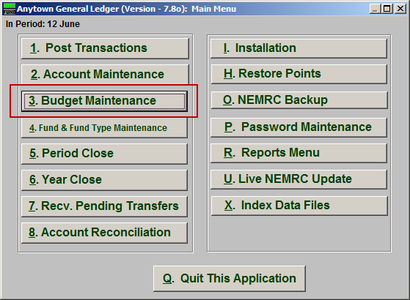
Click on “3. Budget Maintenance” from the Main Menu and the following window will appear:

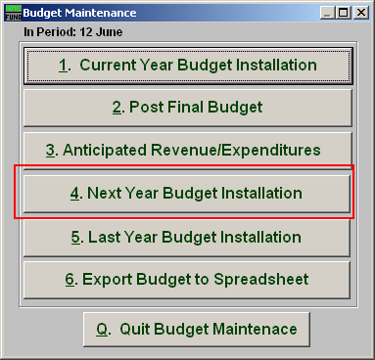
Click on “4. Next Year Budget Installation” from the Budget Maintenance Menu and the following window will appear:

Next Year Budget Installation

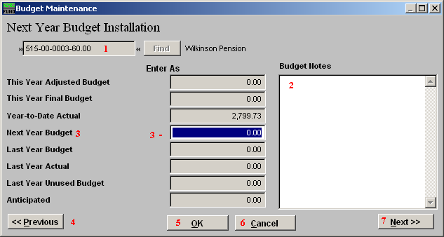
- Account Number to Post: Enter the budget account number to post anticipation amounts to or click the find button to select from a table.

- Budget Notes: This is a free form area to review or enter notes on the budget details about this account. This can help determine anticipated values during entry.

- Next Year Budget: Enter the amount for next year’s budget on this account. Revenue accounts typically post a debit budget and expense accounts a credit budget figure.

- Previous: Click this button to save the present value and bring up the account that by number appears before the one shown.

- OK: Click “OK” to save changes and return to the previous screen.

- Cancel: Click “Cancel” to cancel and return to the previous screen.

- Next: Click this button to save the present value and bring up the account that by number appears after the one shown.

